**AZURE 104 project**

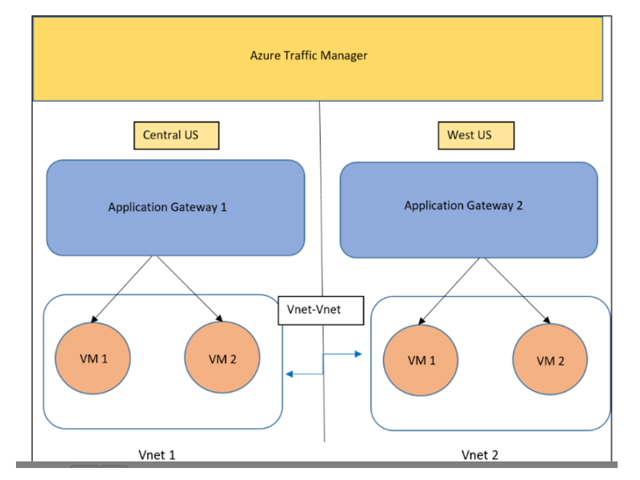

**Azure Projects:**

Project 1: Deploying website using Microsoft Azure

* Deploying the server in two different regions
* Controlling managing and monitoring the traffic geographically
* Enabling path-based routing for the website
* Enabling communication between the servers
* Storing the data on the cloud